**Software Testing Assignment**

**Module–1(Fundamental)**

1. **What is SDLC?**

SDLC Stands for Software Development Lifecycle. A Software Development Lifecycle is essentially a series of steps, or phases, that provide a model for the development and lifecycle management of an application or piece of software.

1. **What is software testing?**

Software testing is a process used to identify correctness, completeness and quality of developed computer software.

1. **What is agile methodology?**

Agile SDLC model is a combination of iterative and incremental process models with focus on process adaptability and customer satisfaction by rapid delivery of working software product. Agile Methods break the product into small incremental builds. These builds are provided in iterations. Each iteration typically lasts from about one to three weeks. Every iteration involves cross functional teams working simultaneously on various areas like planning, requirements analysis, design, coding, unit testing, and acceptance testing.

1. **What is SRS?**

A Software requirements specification (SRS) is a complete description of the behavior of the system to be developed.

1. **What is oops?**

Object Oriented Programming (OOP) is a programming technique in which programs are written on the basis of objects.

Ex:- Python, Java, C++, PHP, Ruby, etc.

1. **Write Basic Concepts of oops**
2. OBJECTS
3. CLASS
4. ENCAPSULATION
5. INHERITANCE
6. POLYMORPHISM
7. ABSTRACTION
8. **What is Object?**

“Object is part/instance/example/representative entity of class”.

1. **What is Class?**

“A class represents an abstraction of the object and abstracts the properties and behavior of that object.” “ It is a blueprint/collection for an object”.

1. **What is encapsulation?**

“Encapsulation is the practice of including in an object everything it needs hidden from other objects. The internal state is usually not accessible by other objects.” “Wrapping up of data into a single unit”.

1. **What is inheritance?**

“Ability to adapt the behavior of parent class to child class”. Here two or more class are in parent child relation.

1. **What is polymorphism?**

“ Polymorphism means “having many forms”. It allows different objects to respond to the same message in different ways, the response specific to the type of the object.” “ Ability to represent in different way”.

1. **Draw Usecase on Online book shopping**

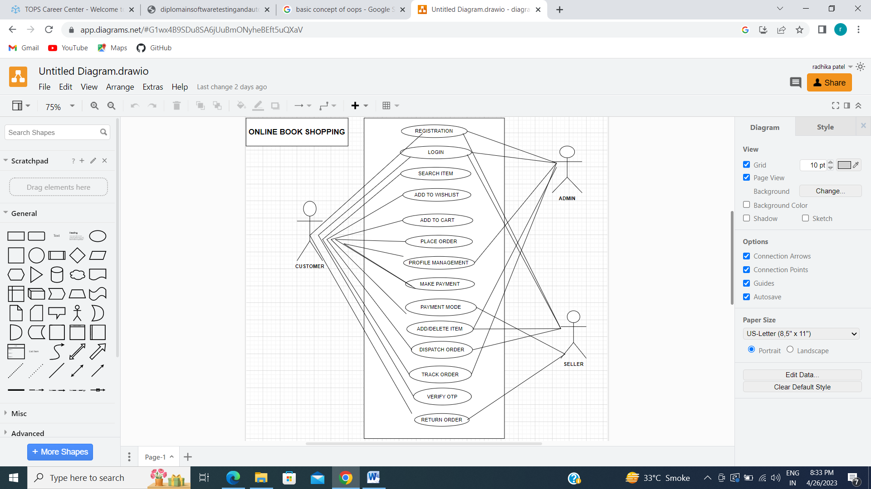

1. **Draw Usecase on online bill payment system (paytm)**

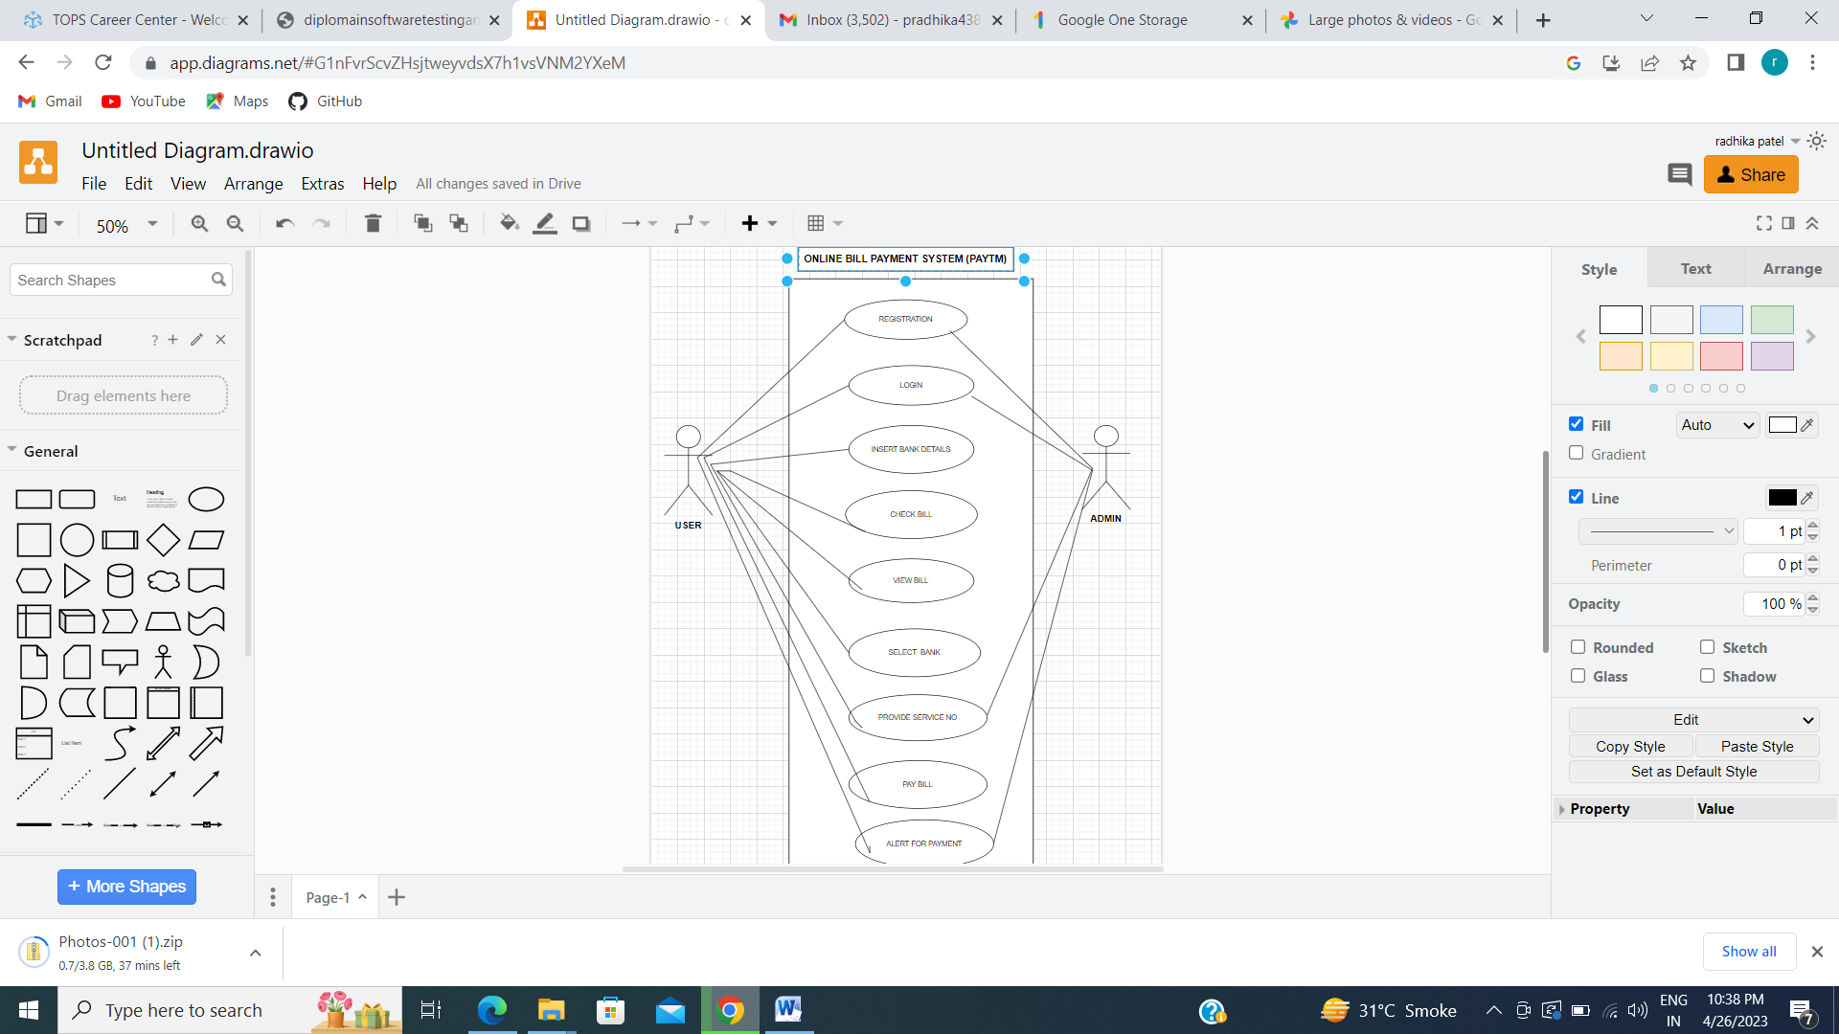

1. **Write SDLC phases with basic introduction**
   * + - 1. Requirements collection/Gathering :- Establish Customer Needs.
         2. Analysis :- Model and Specify the requirements- “What”.
         3. Design :- Model and Specify a solution- “Why”.
         4. Implementation :- Construct a solution in software
         5. Testing :- Validate the solutions against the requirements.
         6. Maintenance :- Repair defects and adapt the solution to the new requirements.
2. **Explain Phases of the waterfall model** 
   * + - 1. **Requirements** **collection** :- All Possible requirements of the system to be developed are captured in this phase and documented in a requirement specification document.
         2. **Analysis:-** Every software project begins with an analysis phase that includes a feasibility study and a requirements definition. In the feasibility study, the software project is assessed in terms of costs, revenue, and feasibility. The feasibility study provides a requirement specification (a rough description of the requirements), a project plan and the project calculation, as well as an offer for the client, if applicable.
         3. **Design** :- The requirement specifications from first phase are studied in this phase and the system design is prepared. This system design helps in specifying hardware and system requirements and helps in defining the overall system architecture.
         4. **Implementation:-** With inputs from the system design, the system is first developed in small programs called units, which are integrated in the next phase. Each unit is developed and tested for its functionality, which is referred to as Unit Testing.
         5. **Testing:-** All the units developed in the implementation phase are integrated into a system after testing of each unit. Post integration the entire system is tested for any faults and failures.
         6. **Maintenance:-** There are some issues which come up in the client environment. To fix those issues, patches are released. Also to enhance the product some better versions are released. Maintenance is done to deliver these changes in the customer environment.
3. **Write Phases of spiral model?**
4. **Planning**:- Determination of objectives, alternatives and constraints.
5. **Risk Analysis**:- Analysis of alternatives and identification/resolution of risks.
6. **Engineering**:- Development of the “next level” product.
7. **Customer Evaluation:-** Assessment of the results of engineering.
8. **Write agile manifesto principles**
9. Customer satisfaction through early and continuous software delivery
10. Accommodate changing requirements throughout the development process
11. Frequent delivery of working software
12. Collaboration between the business stakeholders and developers throughout the project
13. Enable face to face interactions
14. Working software is the primary measure of progress
15. Agile process to support a consistent development pace
16. Attention to technical detail and design enhances agility
17. Simplicity
18. Self organizing teams encourage great architectures, requirements and designs
19. Regular reflection on how to become more effective
20. **Explain working methodology of agile model and also write pros and cons.**

Agile SDLC model is a combination of iterative and incremental process models with focus on process adaptability and customer satisfaction by rapid delivery of working software product. Agile Methods break the product into small incremental builds. These builds are provided in iterations.

**PROS:-**

Is a very realistic approach to software development.

Promotes teamwork and cross training.

Functionality can be developed rapidly and demonstrated.

Resource requirements are minimum.

Suitable for fixed or changing requirements

Delivers early partial working solutions.

Good model for environments that change steadily.

Minimal rules, documentation easily employed.

Little or no planning required

Easy to manage

Gives flexibility to developers

**CONS:-**

Not suitable for handling complex dependencies.

More risk of sustainability, maintainability and extensibility.

An overall plan, an agile leader and agile PM practice is a must without which it will not work.

Depends heavily on customer interaction, so if customer is not clear, team can be driven in the wrong direction.

There is very high individual dependency, since there is minimum documentation generated.

Transfer of technology to new team members may be quite challenging due to lack of documentation.

1. **Draw usecase on Online shopping product using COD.**

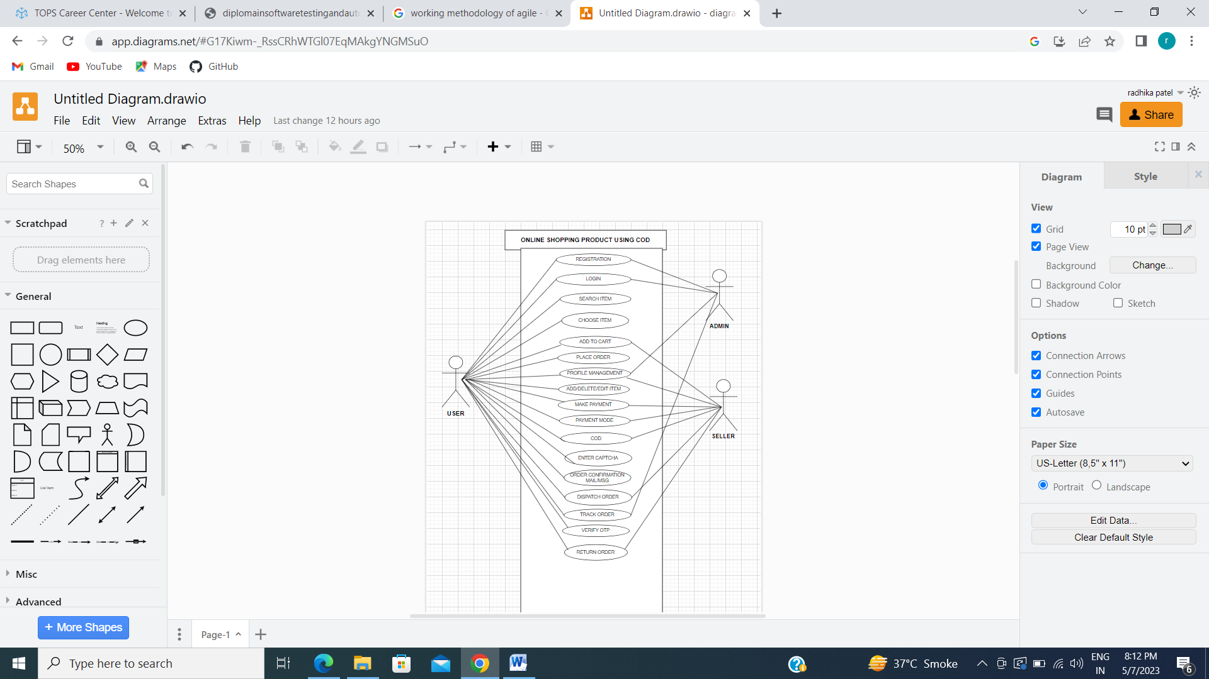

1. **Draw Usecase on Online shopping product using payment gateway.**

